ASSIGNMENT 2 - SQL COMMANDS

By Karthikeyan K R

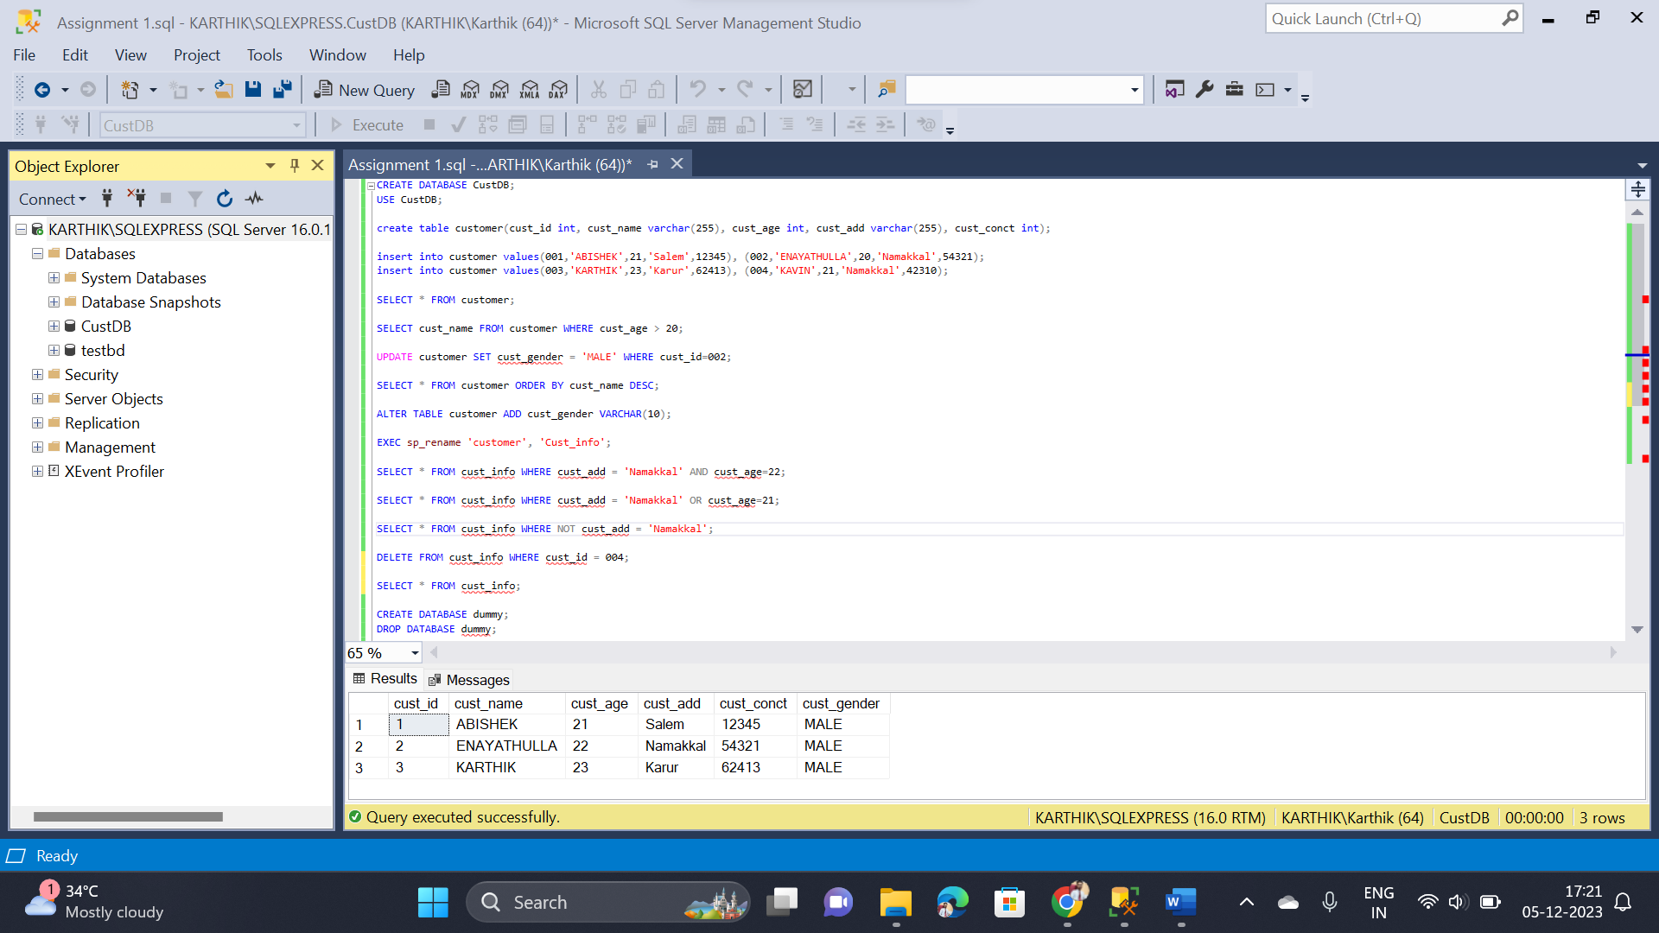

* I have created a database named “custDB”
* In the “custDB” Database, I have created a table named “customer” then with the help of **RENAME** command, I have renamed to “cust_info”
* I have inserted 4 records into cust_info table
* I want to fetch records who are all the persons with the age above 20 so I have used **WHERE** command to do this.
* I have used **ALTER** command with **ADD** condition to add one more column named “cust_gender”
* I have used logical operators **AND**, **OR** and **NOT** to fetch records with one or more conditions
* I have remove one record with “cust_id = 004” by using **DELETE** command
* Finally I have a new database named “dummy” and then simply deleted that database by using **DROP** command